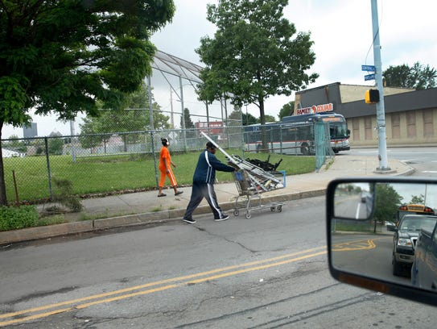

Poverty in Rochester

the unfortunate results of redlining

Quang Huynh | Dynamics of Citizen | 6/8/2023

# Table of Contents

**Section One**: Community Problem

* Restatement of the Problem Page 2
* Existing Policies Page 3

**Section Two**: Finalized Public Policy with an Implementation Plan

* Finalized Public Policy Page
* Action or Implementation Plan Page

**Section Three**: Advocacy

* Letter to Federal Representative Page
* Letter to State or Local Representative Page
* Proof of Mailing Letters Page
* Social Media Post Page
* Works Cited Page Page

# Section One: Community Problem

Restatement of the problem:

In Rochester, New York, poverty has a big impact on both the people living there and the city as a whole. A significant section of the population is experiencing extreme financial difficulty and finding it difficult to meet basic needs, as seen by the high poverty rate of 33.4% in 2019. The social and economic landscape of the city are both impacted in different ways by this. Limiting social mobility and producing gaps in opportunities and outcomes, limited access to resources and basic services perpetuates a cycle of adversity. As poor households struggle to give their children the assistance and resources they need for their schooling, educational attainment is frequently jeopardized. A less educated population hinders overall economic development and lowers the competitiveness of the city, which can have long-term effects on both individuals and the workforce.

Furthermore, poverty has a negative impact on health outcomes because those who live in poverty have difficulty accessing healthcare, healthy food, and safe housing. More people who live in poverty have chronic illnesses, mental health issues, and little access to preventive treatment. The load on the city's resources is further increased by the stress on the healthcare systems and decreased production. In addition, poverty raises social costs since it puts a strain on social safety nets and requires significant resource allocation to meet the urgent needs of the poor. Policies that support economic empowerment, fair opportunity, and improved access to key resources and services must be put into place if poverty is to be addressed holistically. The poverty cycle may be broken, social cohesion fostered, health outcomes improved, and economic growth and stability stimulated in Rochester by investing in job creation, affordable housing, high-quality education, and healthcare.

Existing policies:

At the federal, state, and local levels, poverty is being combated through a combination of governmental policies and neighborhood initiatives. The federal government has put in place programs like the Earned Income Tax Credit (EITC), which offers financial aid to low-income employees, and the Supplemental Nutrition aid Program (SNAP), which offers nutritional help to low-income people and families. By offering financial aid, job training, and social services, the Temporary Assistance for Needy Families (TANF) program, another federal initiative, looks to empower families. By addressing immediate needs and encouraging self-sufficiency, these strategies fight poverty on a nationwide level.

Initiatives like Rochester, New York's Office of Community Wealth Building, which focuses on asset creation, workforce development, and neighborhood rehabilitation, are implemented at the state and local levels. They give low-income people the chance to access inexpensive housing and healthcare. The Rochester-Monroe Anti-Poverty Initiative (RMAPI) also brings together governmental bodies, charitable organizations, and neighborhood associations to improve educational outcomes, supply employment opportunities, and foster community engagement. By working with neighborhood organizations like the Community Place of Greater Rochester and The Children's Agenda, which offer services like food aid, job training, and support for parents and caregivers, these local initiatives look to address the difficulties faced by neighborhoods.

There is a concentrated attempt to address poverty at different levels by fusing state policies with community-driven initiatives. To effectively address the underlying causes of poverty and build a more equal society for all, however, sustained collaboration, resource allocation, and systemic change are needed.

# Section Two: Finalized Public Policy with an Implementation Plan

Finalized Public Policy: